* Install Pycharm editor.
* Point python interpreter to the local installed interpreter.
* Create a project: File > New Project.
* Create a new Python file:

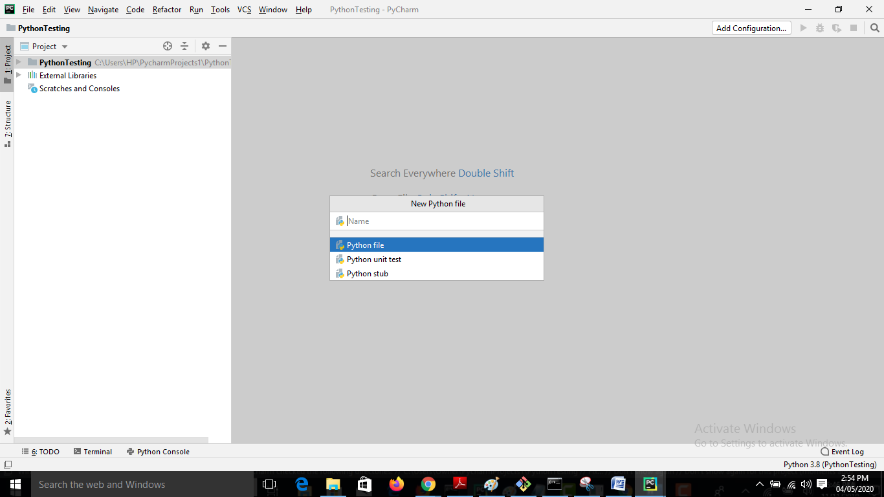

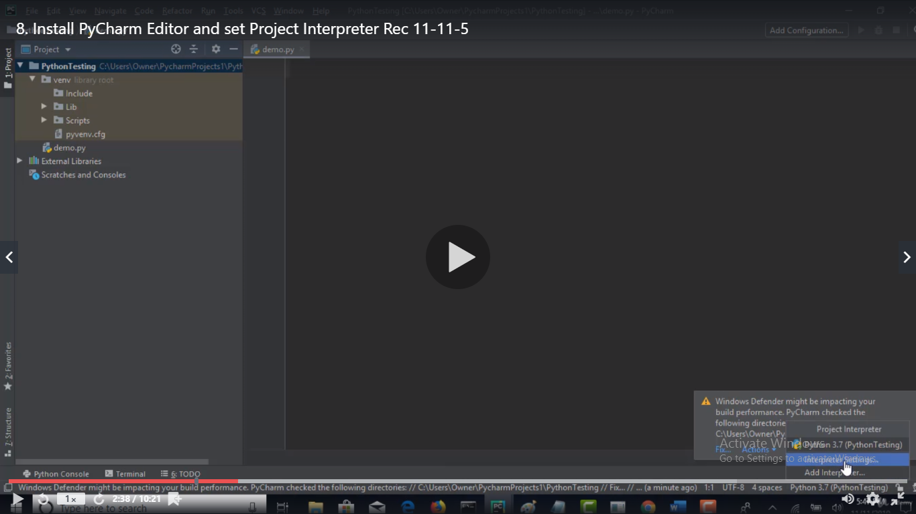

* Now go to interpreter settings.

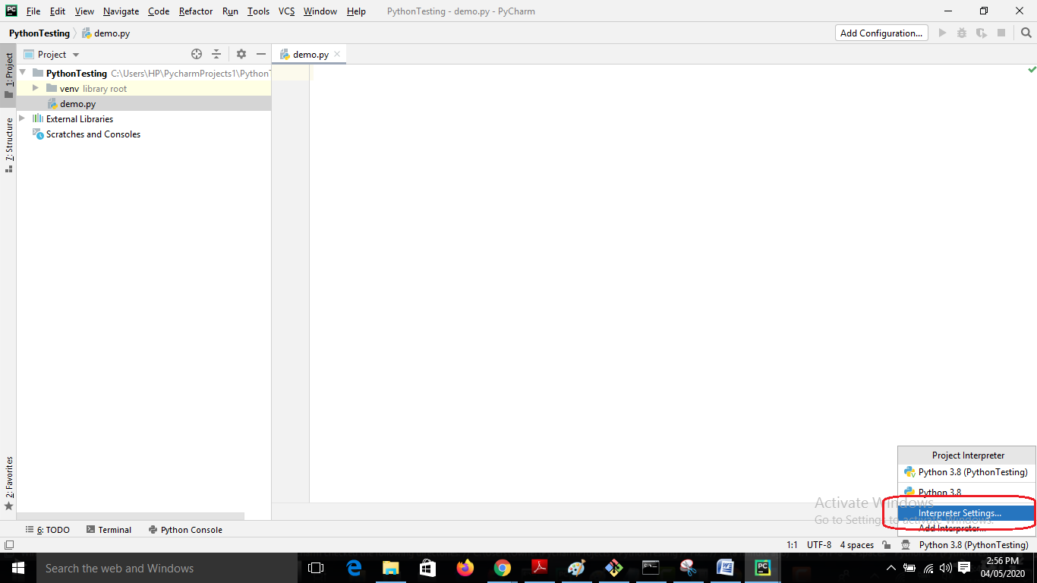

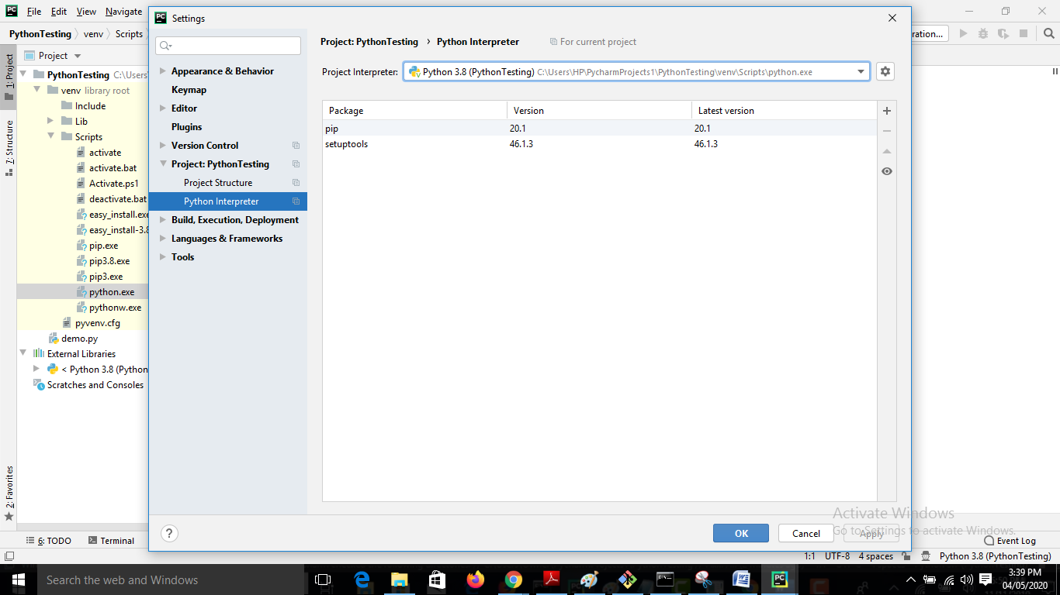

* Settings > show all

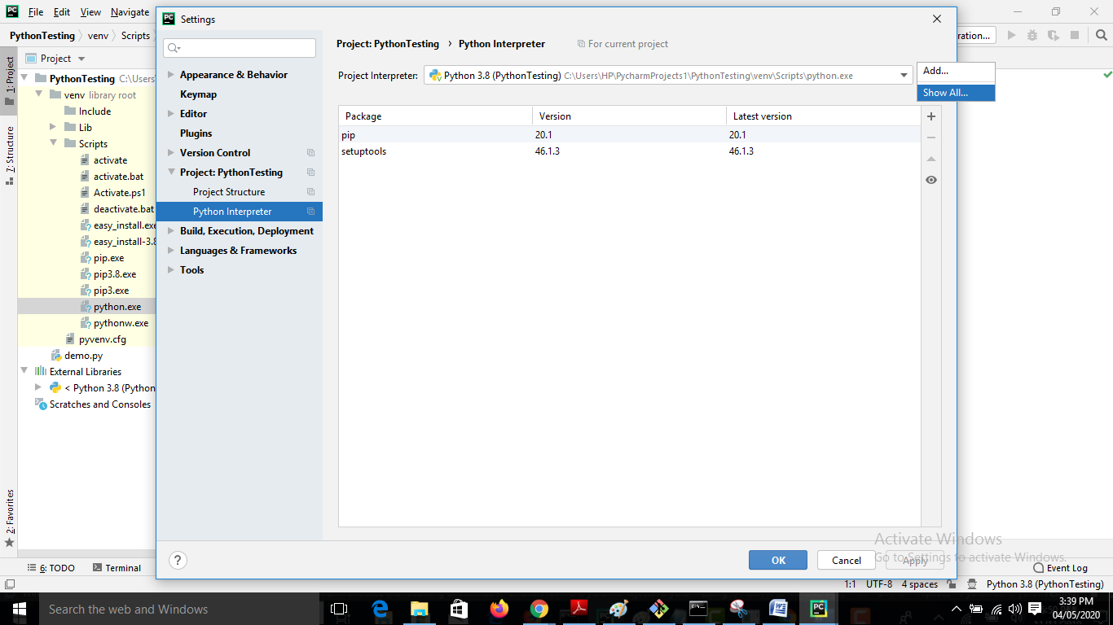

* Change it to the local interpreter where selenium is there.

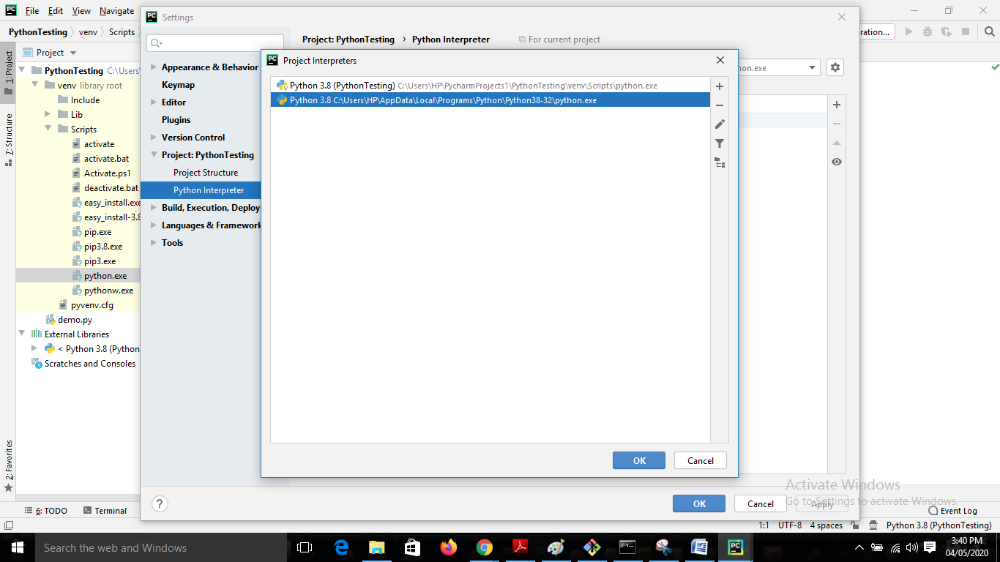

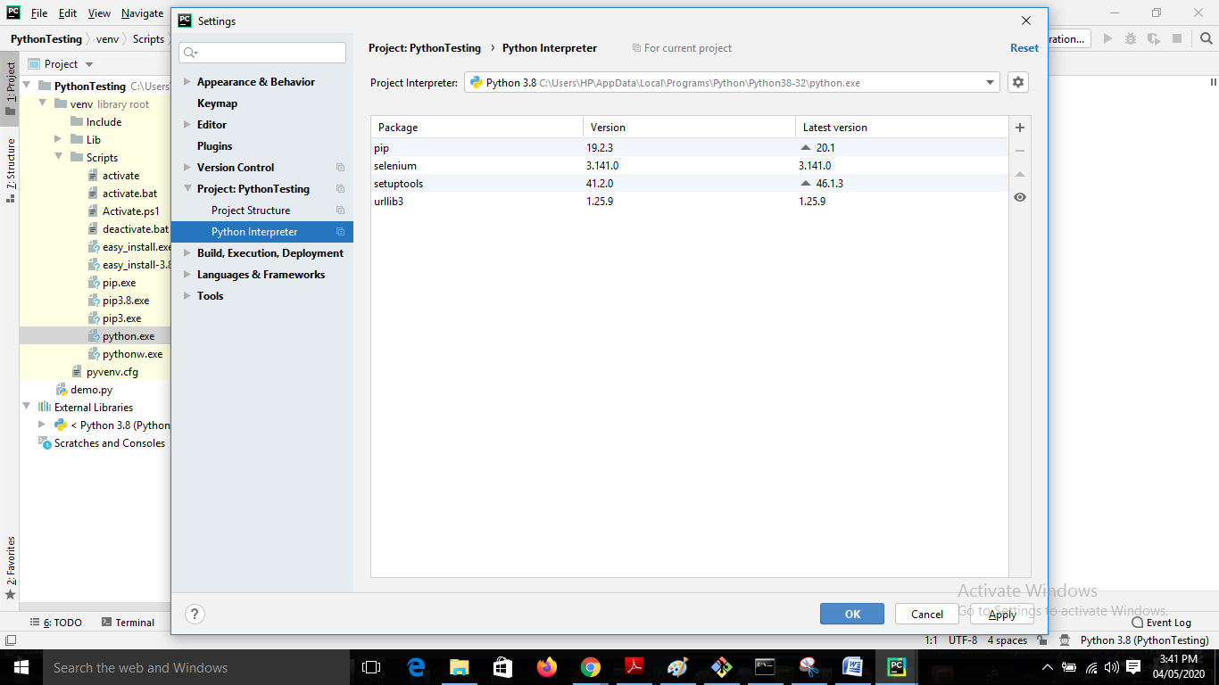

Where to download code files?

You can find  the Python programming code files in Lecture 24 to download